Student  Full Name: | Student  Number:
Subject:  PFD47XS Professional Development/Methods | Test Date:  27 March 2024 | Duration:  2 hours


Faculty of Informatics & Design
Course:
BTech in Information Technology
Question | Student Mark | Max. Score
1 |  | 20
2 |  | 20
3 |  | 20
4 |  | 20
 |  | 100

Subject Coordinator:
Mr T. Makhurane
Lecturers / Examiners:
Mr T. Makhurane
Moderator:
Internal:
External:
Special instructions:
Answer all the questions that are written in bold. Hand-in question paper at the end of examination
Requirements:
Students should not leave within the first hour even if they have completed.
Hand-in question paper together with the answer book at the end of examination

%

Figure 1
Question 1 |  | [20]
Draw the network. AOA or AON are both acceptable.
Activity | Duration | Predecessor
A | 4 | -
B | 6 | A
C | 5 | A
D | 8 | A
E | 9 | B
F | 10 | B
G | 6 | C,E
H | 8 | D
I | 3 | D
J | 2 | G,H

1.1 | Determine the Finish time for the project. | [6]
1.2 | Determine the Critical Path. | [4]
1.3 | For three activities not on the critical path, if any, calculate the Free Float, Independent Float and Total Float. | [10]
Question 2 |  | [20]
2.1 | Activity Immediate Predecessors Optimistic Most Likely Pessimistic  A - 4 5 7  B A 1 3 6  C A 4 5 7  D B 3 7 10  E B 4 6 9  F C, D 2 3 5  G E 1 7 10  H E, F 2 6 8  Draw the network. AOA or AON are both acceptable. | [4]
2.2 | Determine the expected finish time. | [8]
2.3 | Calculate the time by which we have 95% confidence of finishing. | [4]
2.4 | Calculate the probability of finishing 1 days after the expected finish time | [4]

Question 3 |  | [20]
3.1 | Define project management. | [4]
3.2 | Explain the fundamental trade-off in project management. | [4]
3.3 | Name four of Henri Fayol’s principles of management, and explain how they are applicable in a situation where we have a project manager leading a team of five members working on a software development project. | [12]
Question 4 |  | [20]
4.1 | Given the information provided here and the Gantt chart layout provided below, construct a Gantt chart, by filling in the appropriate blocks on the Gantt chart with the character X on this question paper. | [20]

Activity Letter | Activity Description | Predecessor | Duration (days)
A | Train project team | None | 10
B | Project paperwork and systems design | A | 5
C | Modify purchased package | B | 5
D | Manual systems flow | B | 10
E | Modify in-house procedures | B | 15
F | Test and implement modifications to purchased package | C | 15
G | Test and implement manual | D | 15
H | Test and implement modifications to in-house procedures | E | 5

Given this resource sheet
Resource | Cost/Hour
Trainer | R50.00
Application Domain Specialist | R40.00
Solution Domain Specialist | R40.00
Project Manager | R20.00
Tester | R30.00

And this task assignment List
Task | Resources Assigned
- Train Project Team | Trainer
- Project Management Paperwork | Project Manager
- Modify Purchased Package | Solution Domain Specialist, Application Domain Specialist
- Manual systems Flow | Project Manager
- Modify In-House Procedures | Project Manager, Solution Domain Specialist
- Test and Implement Modifications to Purchased Package | Tester, Solution Domain Specialist
- Test and Implement Manual Systems Flow | Tester
- Test and Implement Modifications to In-House Procedures | Tester

Assume the following:
- There are 20 Working days per month.
- There are 8 hours per working day.

Assess the total amount of money needed to run the project. [20]

Formulae

$$ED=\frac{A+4M+B}{6}$$

$$\text{Var}= {\left(\frac{B-A}{6}\right)}^{2}$$

$$z=\frac{x-μ}{s}$$

$$x=zs+μ$$
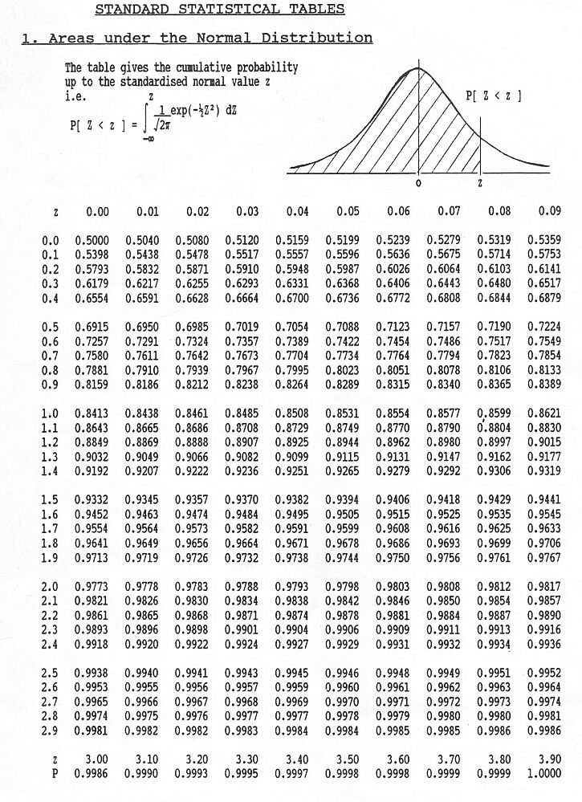

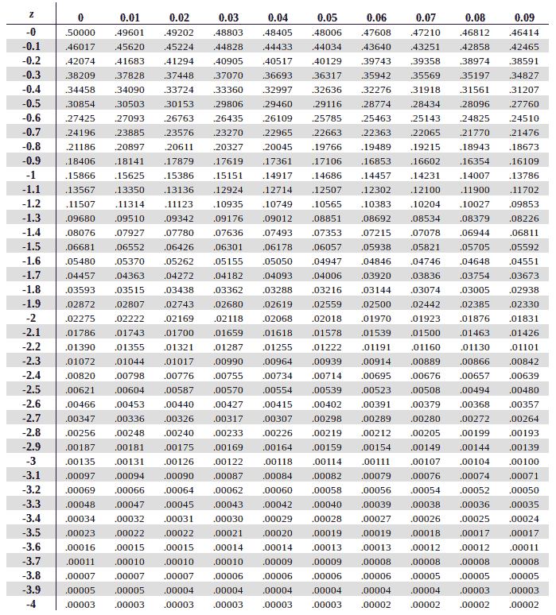

End of Test Paper

